There are n people standing in a queue, and they numbered from 0 to n - 1 in **left to right** order. You are given an array heights of **distinct** integers where heights[i] represents the height of the ith person.

A person can **see** another person to their right in the queue if everybody in between is **shorter** than both of them. More formally, the ith person can see the jth person if i < j and min(heights[i], heights[j]) > max(heights[i+1], heights[i+2], ..., heights[j-1]).

Return *an array*answer*of length*n*where*answer[i]*is the****number of people****the*ith*person can****see****to their right in the queue*.

**Example 1:**

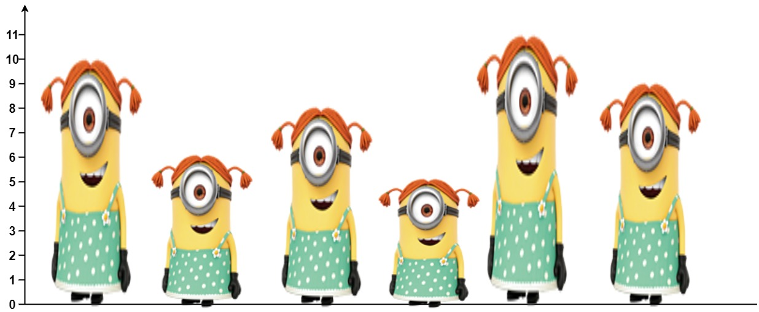

**Input:** heights = [10,6,8,5,11,9]

**Output:** [3,1,2,1,1,0]

**Explanation:**

Person 0 can see person 1, 2, and 4.

Person 1 can see person 2.

Person 2 can see person 3 and 4.

Person 3 can see person 4.

Person 4 can see person 5.

Person 5 can see no one since nobody is to the right of them.

**Example 2:**

**Input:** heights = [5,1,2,3,10]

**Output:** [4,1,1,1,0]

**Constraints:**

* n == heights.length
* 1 <= n <= 105
* 1 <= heights[i] <= 105
* All the values of heights are **unique**.